* Normal Regression
  + 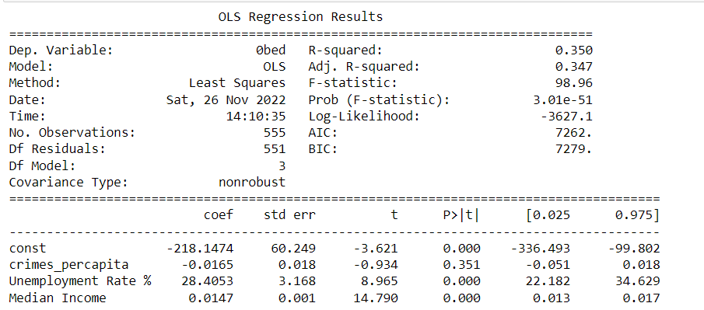
* Logged Unemployment Rate and 0bed
  + 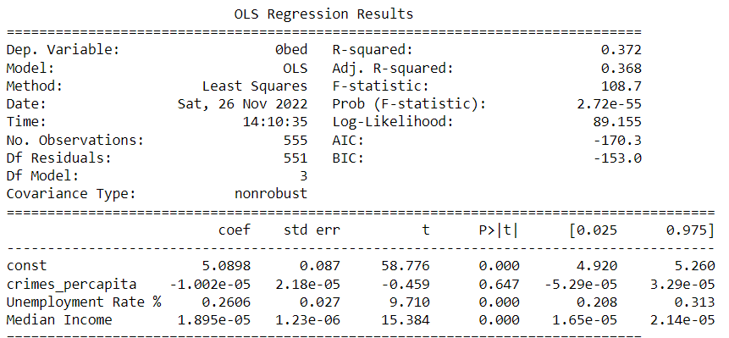
* Log Crime, 0 Bed
  + 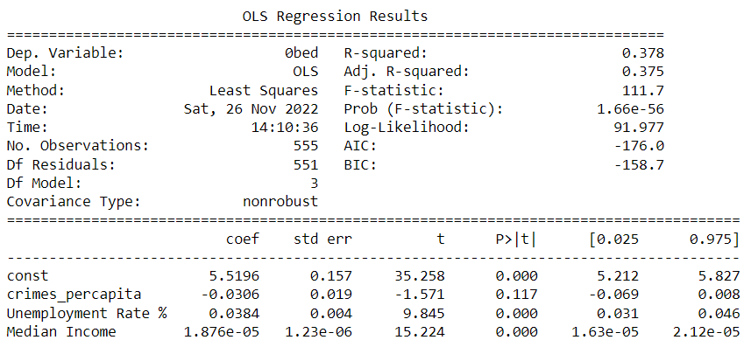
* **Log All, 0 Bed**
  + H0: Crime has no effect on rent for 0 Bedroom Apartments
  + Ha: Crime Does have an affect on rent for 0 Bedroom Apartments
    - Accept Null Hypothesis, Crime has no effect on rent for these apartments. The P-value for crimes per capita is too high for any significance levels.
  + 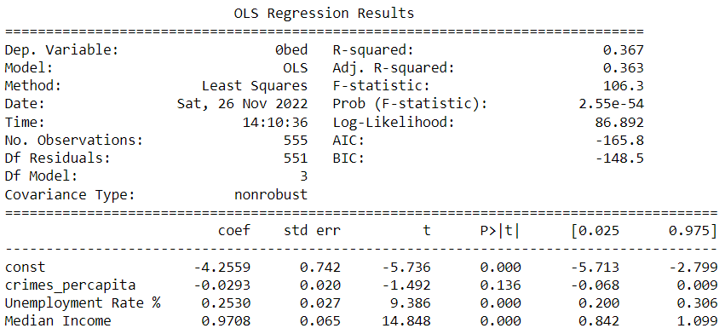
  + All Variables are logged!
  + Unemployment rate %, with every 1% increase in there is a .253% increase in rent
  + Median Income, with every 1% increase there is a .9708% increase in rent
* **1 Bed, Log All**
  + H0: Crime has no effect on rent for 1 Bedroom Apartments
  + Ha: Crime Does have an affect on rent for 1 Bedroom Apartments
    - Accept the Null Hypothesis, Crime has no effect on rent for 1 bedroom apartments.
  + 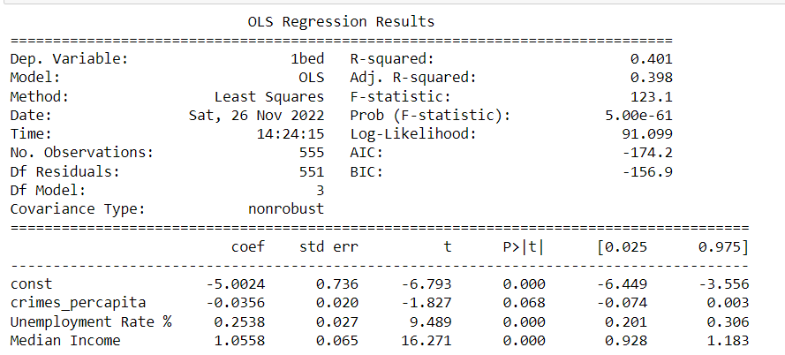
  + The effect that unemployment rates have on 1 bedroom apartments is virtually unchanged from 0 bedroom apartments.
  + But Median income saw a significant increase where a 1% increase now causes a 1.0558% in rent.
* **2 Bed, Log All**
  + H0: Crime has no effect on rent for 2 Bedroom Apartments
  + Ha: Crime Does have an affect on rent for 2 Bedroom Apartments
    - In this regression, we can reject the null because all of the p-values are less than 0.05.
    - With the knowledge that all variables are logged, we can interpret the coefficients in terms of percentages.
    - Crimes per capita, with every 1% increase there is a 0.0549% decrease in rent
    - Unemployment rate %, with every 1% increase there is a 0.2296% increase in rent. The effect that unemployment rates have only changes by approximately 0.03% for 2 bedrooms in comparison to the 1 bedroom nd 0 bedroom apartments.
    - Median Income, with every 1% increase there is a 1.1115% increase in rent
  + 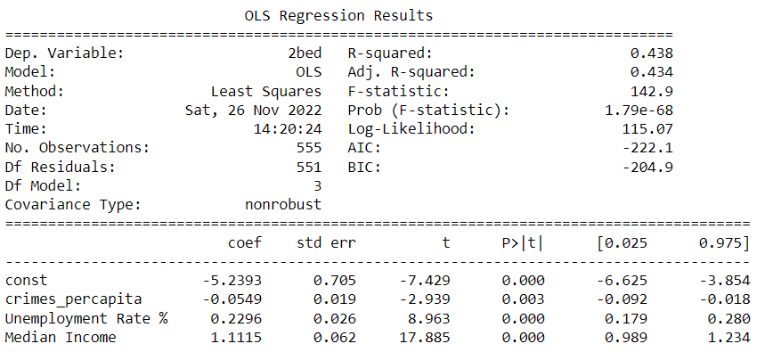
* **3 Bed, Log all** 
  + H0: Crime has no effect on rent for 3 Bedroom Apartments
  + Ha: Crime Does have an affect on rent for 3 Bedroom Apartments
    - In this regression, we can reject the null because all of the p-avlues are less than 0.05.
    - With the knowledge that all variables are logged, we can interpret the coefficients in terms of percentages.
    - Crimes per capita, with every 1% increase there is a 0.1229% decrease in rent
    - Unemployment rate %, with every 1% increase there is a 0.2150% increase in rent. The effect that unemployment rates have on 3 bedroom apartments is changed by approximately 0.01% from 2 bedroom apartments.
    - Median Income, with every 1% increase there is a 1.1550% increase in rent
  + 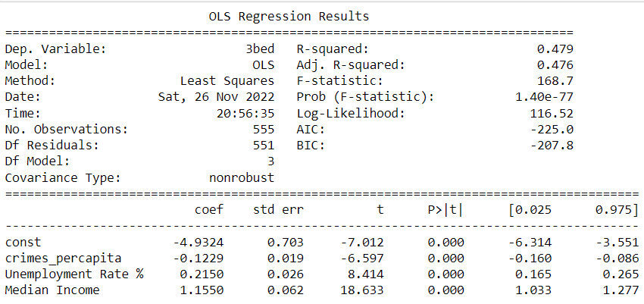
* **4 Bed, Log all**
  + H0: Crime has no effect on rent for 4 Bedroom Apartments
  + Ha: Crime Does have an affect on rent for 4 Bedroom Apartments
    - In this regression, we can reject the null because all of the p-avlues are less than 0.05.
    - With the knowledge that all variables are logged, we can interpret the coefficients in terms of percentages.
    - Crimes per capita, with every 1% increase there is a 0.1382% decrease in rent
    - Unemployment rate %, with every 1% increase there is a 0.2103% increase in rent. The effect that unemployment rates have on 3 bedroom apartments is virtually unchanged from 4 bedroom apartments. The effect only change by approximately 0.0047%
    - Median Income, with every 1% increase there is a 1.12036% increase in rent
  + 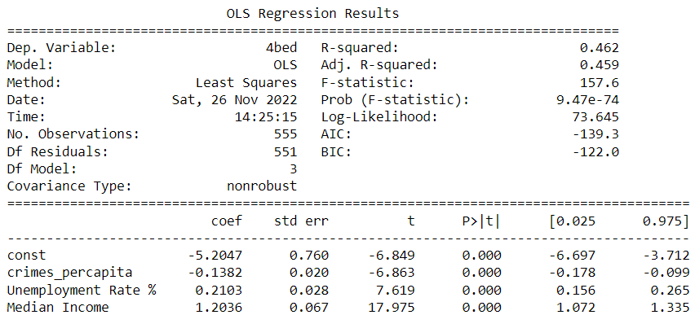
* 2 Bed, Log Crime & Income
  + 